**Project 1: Exhaustive Analysis of Indian agriculture**

**Week 1- Activity**

**Let’s start**

To perform this project, we need to have knowledge on data analytics and power Bi in order to analyse Indian agriculture data based on various factors.

Our week-1 lecture is about introduction of power Bi.

Let’s install power bi and perform some operations.

Step 1:

1.Open web browser and install power Bi by following instructions.

2. Open power bi desktop.

3. Select blank report.

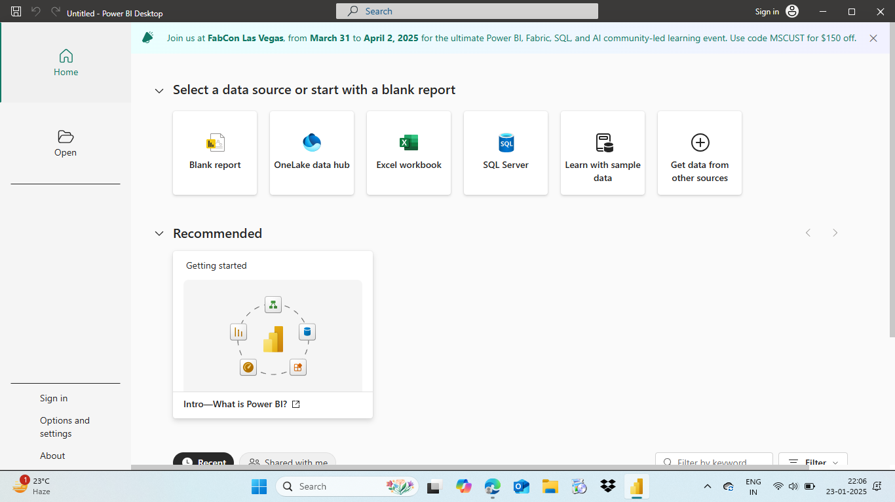

4. To perform operations, we need to get data from any data source.

5. Select option according to data file format.

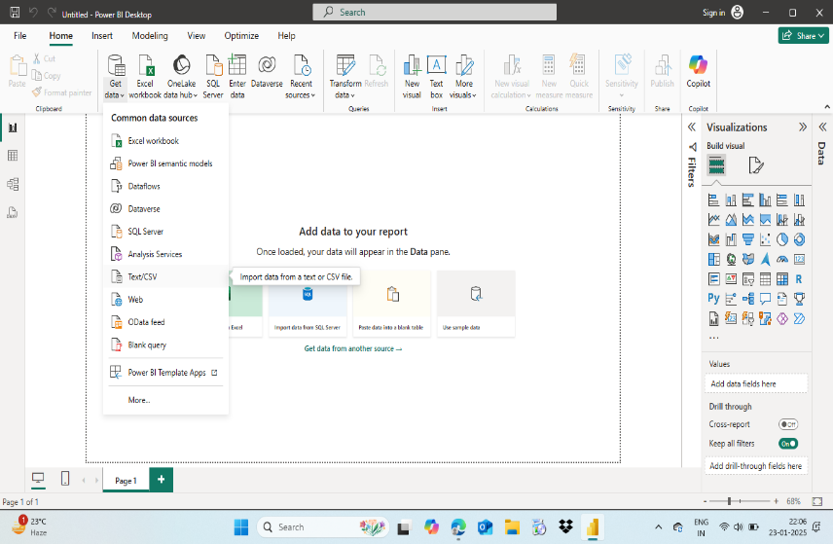

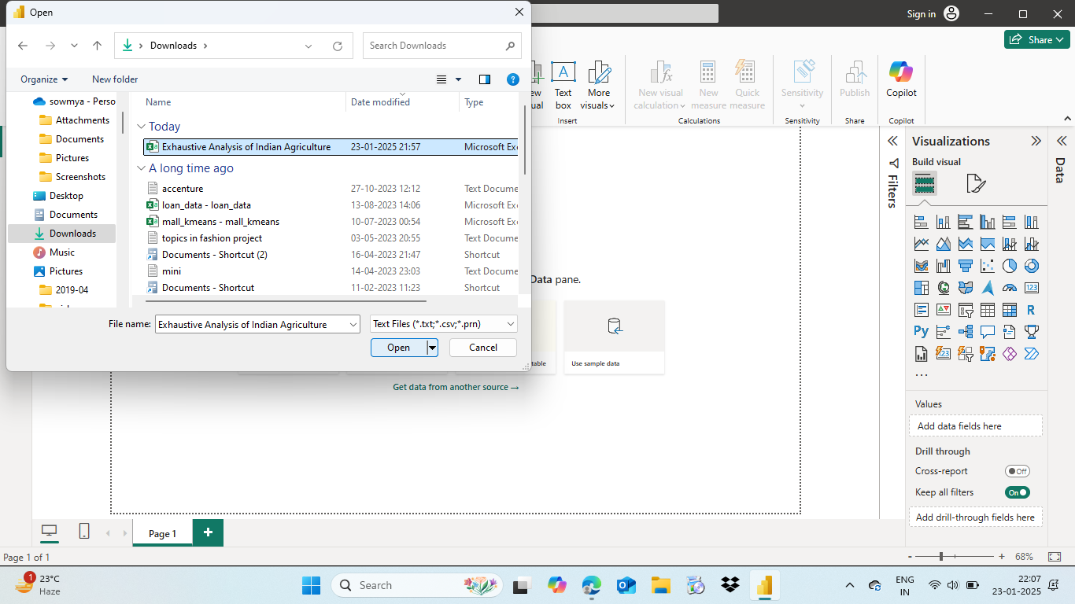

6. Based on our requirements we can modify data and load it, if no requirements needed just go for load.

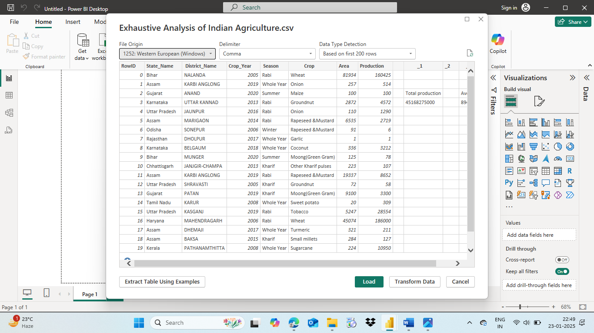

7.If any modifications need to be done on loaded data, select transform data and perform operations and don’t forget to click close and apply if previous changes need to be saved.

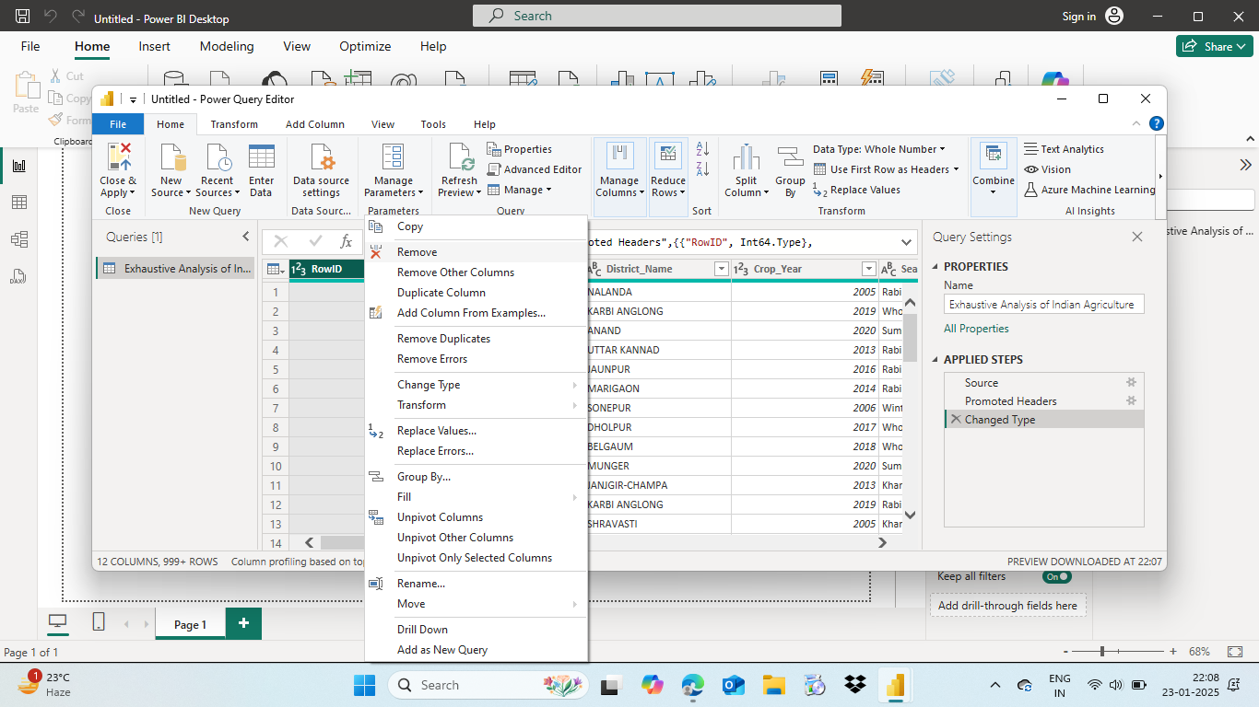

8.Now we can close the window.

This is all about what we have learnt from first week lecture.

Let’s wind up with first week task**, THANKYOU.**